FBLA Scavenger Hunt
www.azfbla.org
- What does FBLA stand for? _____________________________________________

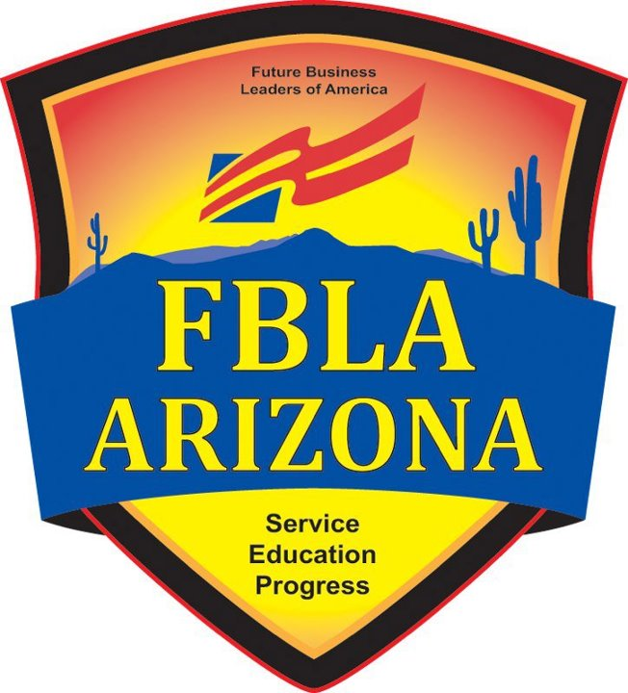
- What does PBL stand for? _____________________________________________
- What is the state theme for FBLA Arizona? _____________________________________________
- How many years has FBLA been in Arizona? _____________________________________________
- What is one of the FBLA goals? _____________________________________________
- List four competitive events that you can enter: ____________________________________________________________________________________________________________________________________________________________________________________
- Where is one of the four regional conferences is located this year? _____________________________________________
- Who is the State President of FBLA AZ and where does he/she go to school? _____________________________________________
- Who is the State Director of FBLA AZ? _____________________________________________
- When and where is the State Leadership Conference? _____________________________________________
- What is the community service partner that FBLA helps raise funds and awareness for? _____________________________________________
- The high school level of FBLA has how many members nationwide? _____________________________________________
- The mission of FBLA is to bring ____________ and _____________ together in a positive working relationship through innovative leadership and career development programs.
- Where is the opening session of the 2012 FLEX conference? _____________________________________________
- Where is the 2013 National Leadership Conference being held at? _____________________________________________

